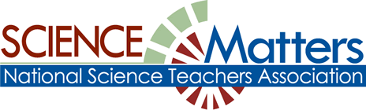

CONNECTICUT SCIENCE CONNECTION
December 2014
The Connecticut Building a Presence for Science Network is sustained through the advocacy of the CCAT, Connecticut Science Supervisors Association, and the Connecticut Science Teachers Association

State Coordinator.David Lopath lopath@comcast.net
List Moderator..Eloise Farmer eloisef302@gmail.com

Names and e-mail addresses of our Points of Contact and Key Leaders are not shared with any other entit

Happy Holidays to all from the SCIENCE MATTERS Crew! 

Resources
CSDE’s science curriculum web site.
More on Standards at: http://www.nextgenscience.org/

EQuIP Rubric for Science Released! The Educators Evaluating the Quality of Instructional Products (EQuIP) Rubric for Lessons & Units: Science provides criteria with respect to the NGSS.
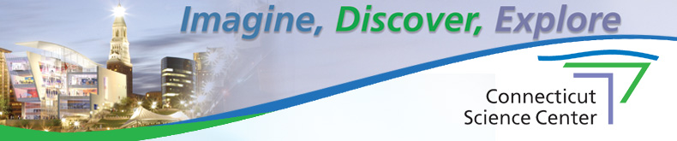
To get all the latest happenings at the Connecticut Science Center, click on the link to its newsletter! Special shows, attractions, and even vacation camps ! Attractions for adults and children..Give the gift of membership! www.ctsciencecenter.org/newsletter/
Visit the NGSS@NSTA Hub :
The NGSS@NSTA Hub now offers a dynamic version of the Next Generation Science Standards.. Accompanying each standard are student performance expectations, and the corresponding science and engineering practices, disciplinary core ideas, Connections to Common Core Standards!

OPPORTUNITIES FOR TEACHERS:

The National WWII Museum is excited to announce a week-long professional development opportunity to take place in the summer of 2015 for middle school (5-8th grade) science teachers. Twenty eight teachers from across the country will come to New Orleans to experience hands-on how necessity, knowledge, perseverance and skill lead to inventions, innovation, and careers in STEM—just like in World War II.
This seminary is supported by a grant from the Northrop Grumman Foundation. Teachers will receive free room and board in New Orleans, a travel stipend, and all seminar materials free of charge.
We are looking for great young teachers nationwide, and the application period begins January 5th 2015. Please visit http://www.nationalww2museum.org/realworldscience for more information and to sign up for email updates.

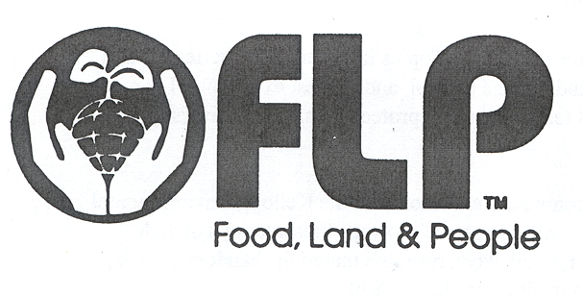
Project Food, Land and People is designed to provide educational materials emphasizing natural resources, soils, food, nutrition, and food systems. It promotes an educational approach that allows students to understand the large picture of the interrelationships among, natural resources, agriculture, the environment and the people of the world, while meeting National and State education standards and applying personal choice. Workshops provide participants with classroom ready activities and supporting materials along with local contacts and materials to help integrate concepts into classroom needs. Contact susan.quincy@ct.gov , 203-734-2513. Workshop fee is $40.00 for any workshop, except January 16th.
January 16, 2015
Facilitator Training Workshop
9:00 am – 5:00 pm
Kellogg Environmental Center
500 Hawthorne Ave., Derby, CT
Become part of the educational network using Project Food, Land and People materials in educational workshops working with teachers and educator across the state. You will learn integration techniques to use in presenting workshops and how to help groups of educators understand the concepts of the material and applications into classrooms and programs. This training requires you have attended a FLP workshop before hand and or be familiar with topics it reaches, i.e. nutrition, gardening, agriculture natural resources… Training for this workshop is free and will provide you with materials.

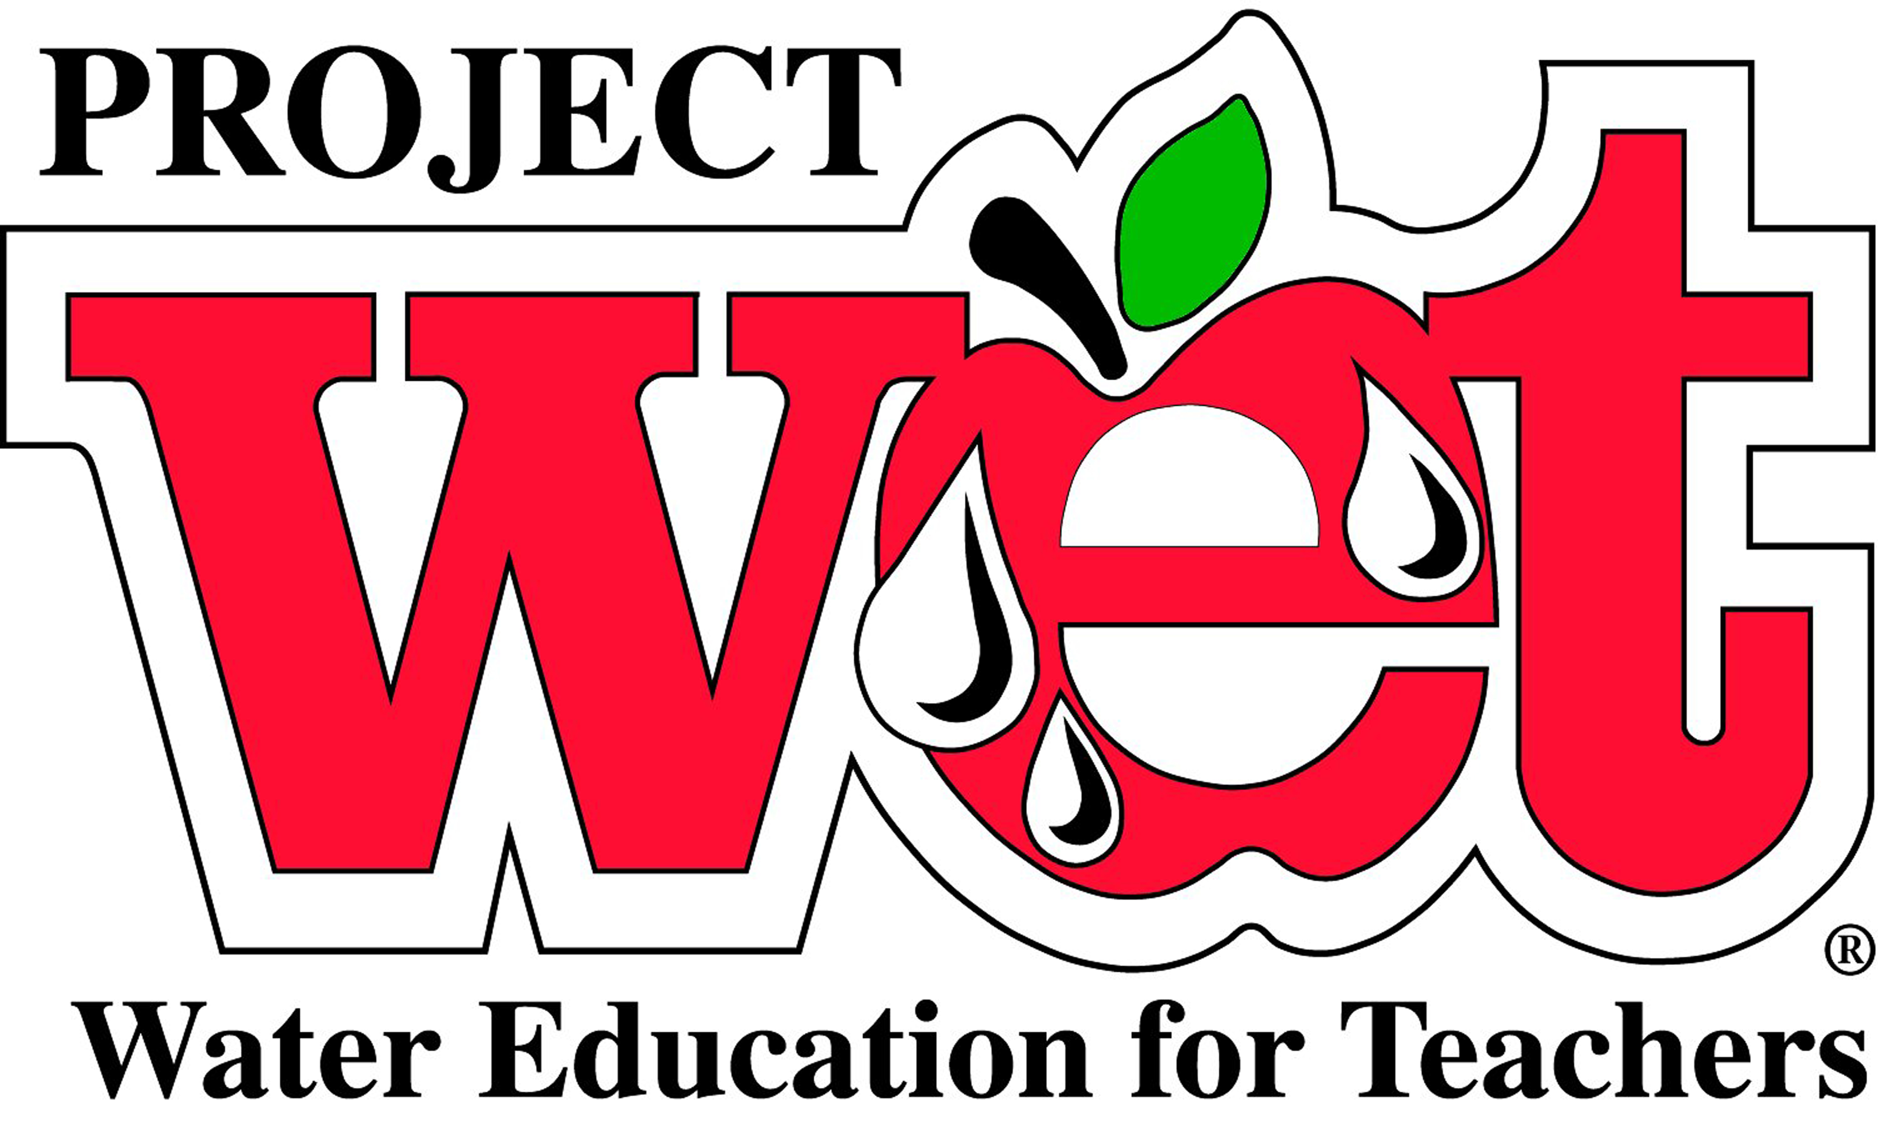
February 11, 2015
Eat Well Be Well
9:00 am – 3:00 pm
Kellogg Environmental Center
500 Hawthorne Ave., Derby, CT

The New Year has started and how is that resolution doing? Help students understand the basics of nutrition and the pathway of nutrients from environment to us. Learn how to connect cafeteria activities and support new lunch standards through better nutrition in the classroom. This educational resource has great connections to Common Core math and Literature standards with activities that apply to grades k-12.
March 11, 2015
Workshop
9:00 am – 3:00 pm
James L. Goodwin Conservation Center
James L. Goodwin State Forest
23 Potter Road, Hampton, CT 06247

Use this day of professional development to delve into how agriculture affects us and we affect agriculture. Focus will be on increasing agriculture and environmental literacy beginning with soil and water and ending with human populations and sustainability issues. Activities are provided for K-12 that increase understanding of natural resource use, technology and design, land use choices, and nutrition. All activities support the Common Core standards and NGSS.
Registration for workshops is required. Fee $40.00 per participant.
Registration forms available by emailing
Susan Quincy at susan.quincy@ct.gov or call 203-734-2513
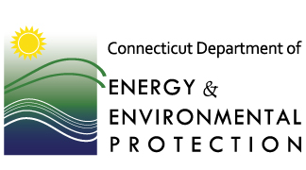

$1000 SCHOLARSHIPS FOR AMAZON RAINFOREST PD WORKSHOP

Project WET (Water Education for Teachers) is an interdisciplinary water education program that provides K-12 educators with hands-on activities and programs that can be used in a variety of educational settings. The goal of project WET is to facilitate and promote the awareness, appreciation, knowledge and stewardship of water resources through the development and distribution of classroom ready teaching aids. Recently revised and updated the WET Guide 2.0 offers new activities on topics such as National Parks, health and hydration, storm water, and the very best activities gathered from all of Project WET’s publications. Contact susan.quincy@ct.gov, 203-734-2513. Workshop fee is $40.00

Workshops Open to all
January 22, 2015
Where Does Water Go?
9:00 am – 3:00 pm
Kellogg Environmental Center
500 Hawthorne Ave., Derby, CT
Focus on needs of elementary teachers to help provide activities and applications illustrating how water moves in our environment and homes. You will begin with the basics of how water works, bonds, mixes and changes forms and then apply it to landforms, water systems and natural environments.
January 30, 2015
Water Health
9:00 am – 3:00 pm
Earthplace- the Nature Discovery Area
10 Woodside Ln, Westport, CT
Water is essential to life. This workshop will illustrate the importance of having clean water and understanding what clean water means for the environment and for us. Hygiene, health and water quality activities will be the focus in this geared for all age levels.
March 6, 2015
Water and Energy Connections
9:00 am – 3:00 pm
Eastern Connecticut State University
Student Center Room 221
Willimantic, CT
Get ready for World Water Day with this workshop focused on helping students and adults understand the connections between water and energy conservation. This year World Water day will consolidate and build on previous year themes. Using Project WET and additional resources we will help illuminate the challenges of meeting needs with sustainable action that conserves natural resources and water. Activities will focus on grades 4-12 with ways to help you celebrate World Water Day in the classroom or community.

Registration for workshops is required. Fee $40.00 per participant.
Registration forms available by emailing
Susan Quincy at susan.quincy@ct.gov or call 203-734-2513

Educator Academy in the Amazon Rainforest + Machu Picchu
The July 1-11, 2015 Educator Academy in the Amazon Rainforest of Peru is a cross-curricular professional development workshop for K-12 formal and informal educators to learn and use:
21st Century Instruction: 5E Lesson Design ~ Inquiry-based Exploration ~ STEM
Inquiry Protocols & Resources: Project Learning Tree ~ Cornell Lab of Ornithology ~ & More!
Global and Cultural Perspectives: Service Learning ~ Sustainability ~ Global Education. Join Al Stenstrup, Project Learning Tree (PLT); Lilly Briggs (Cornell Lab of Ornithology), Christa Dillabaugh, Amazon Rainforest Workshops; and Dr. David Pearson, Wildlife Travellers’ Guide to Peru; and work side-by-side with scientists Dr. Steve Madigosky, Widener University; and Randy Morgan, Curator/Entomologist, Cincinnati Zoo as you:
Participate in citizen science projects and inquiry based field studies on a 1/4-mile Rainforest Canopy Walkway in one of the most biologically diverse environments on the planet.
Spend a day in an Amazon village as you explore the complexities of sustainability and the role of education in creating a sustainable future for Amazon children.
Work with fellow educators to explore strategies for using the Amazon as a vehicle for incorporating STEM education, inquiry-based learning, and sustainability science education into your classroom. PLT Certification, BirdSleuth resources and 50 ASU PD Hours included. Academic Credit and Machu Picchu Extension optional. $1000 scholarship deadline March 1, 2015. Program cost is $1240 + air for scholarship recipients. Space is limited! Register early to secure your spot! Get the details and download a syllabus and scholarship application at: http://www.amazonworkshops.com/educator-academy.html Contact christa@amazonworkshops.com or 1-800-431-2624 for more information.
GEEO
Global Exploration for Educators Organization (GEEO) is a 501c3 non-profit organization that runs professional development travel programs designed for teachers.
GEEO is offering the following travel programs for 2015: India/Nepal, Sri Lanka, Bali/Lombok, Italy, Eastern Europe, Greece, Uzbekistan, Vietnam/Cambodia, Thailand/Laos, Belize/Guatemala, Morocco (Winter, Spring and Summer) China, Eastern Turkey, Western Turkey, Zambia/Botswana/Namibia/South Africa, New Zealand, Costa Rica, Peruvian Andes (Summer and Spring), Peruvian Amazon, and The Galapagos Islands. The registration deadline is June 1st, but space is limited and many programs will be full well before the deadline.
Educators have the option to earn graduate school credit and professional development credit while seeing the world. The trips are 8 to 19 days in length and are designed and discounted to be interesting and affordable for teachers. GEEO provides teachers educational materials and the structure to help them bring their experiences into the classroom. The trips are open to all nationalities of K-12 and university educators and administrators, as well as retired educators. Educators are also permitted to bring along a non-educator guest.
Detailed information about each trip, including itineraries, costs, travel dates, and more can be found at www.geeo.org. GEEO can be reached 7 days a week, toll free at 1-877-600-0105 between 9AM-9PM EST.

UPCOMING EVENTS:
CT SCIENCE SAFETY NETWORK WORKSHOP SERIES:
- December 11 – Chemical Hygiene Officer Training: Responsibilities and Liabilities!
- February 12 – STEM Safety (new)
- March 5 – Safety in the Arts (new)
- March 19 – Science Safety for Special Education Teachers and Paraprofessionals (new)
FOR INFORMATION, CONTACT: Sara MacSorley, Director of the Green Street Arts Center and Project to Increase Mastery of Mathematics and Science (PIMMS ) smacsorley@wesleyan.edu 860-685-7870:
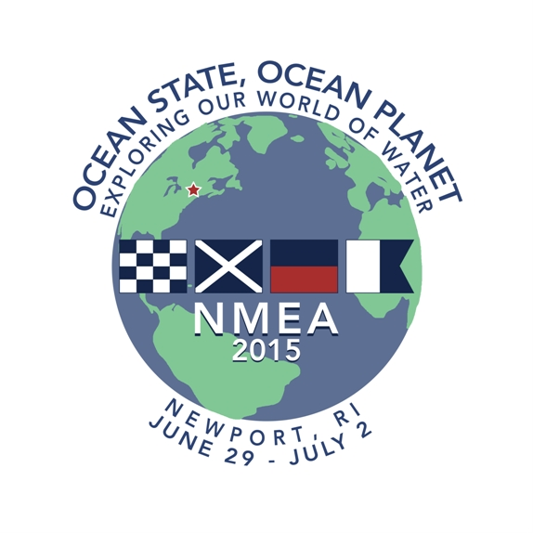
What is NMEA 2015? June 29 - July 2, 2014 SENEME, SouthEastern New England Marine Educators is proud to be the host of the 2015 National Marine Educators Association annual. You can choose the days you would like to attend –or just one day -to concentrate on the strand that interests you most or all or up to five days to absorb the full impact of marine science education; from lectures and workshops to our vast array of experiential learning opportunities in the Newport Area.
Join us at the Newport Marriott, June 28 to July 2, 2015. The National Marine Educators Association Annual Conference is attended by both formal and informal educators, and students from public and private institutions as well as from aquariums, for profit and nonprofit organizations including government agencies. This three to five day event will be filled with an amazing amount of current marine science information. Some of which is related to STEM education and next generation Science standards.
More information can be found online At the NMEA site
http://marine-ed.site-ym.com/general/custom.asp?page=NMEA_2015 Or on our site SENEME
http://seneme.org

Grants and Resources For K-12 Teachers
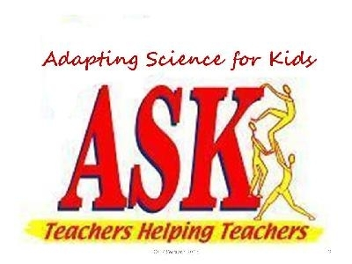
Would you like to share a science lesson video that illustrate how the Next Generation Science Standards can facilitate learning at the elementary (K-6) level? Can you share one or more of your lessons to illustrate this for K-6 teachers? If you have the lesson but not the video, NSF can fund us to provide a free at-a-distance videographer (via PolyCom) to record your lesson. We have 73 K-6 lesson videos (physical, biological, and earth & space sciences), all of them recorded prior to the availability of the NGSS. We would like K-6 teachers to see how teachers are using the NGSS to facilitate learning in science and how the application of these standards can facilitate learning in other areas of the curriculum.
The National Science Foundation funds the "Teachers Helping Teachers Teach Inquiry Science: Just ASK" project. Our website (now open to all teachers) offers a portal that functions as an “specialty shop” where, so far, about 800 K-6 teachers are going to receive and give ideas about inquiry science and how it helps their students learn in areas other than science.
You can check out our project at http://jusstaskateacher.com and you can see our newsletters on that website or at the links below.
Questions, comments, suggestions? We would like to hear from you. Use our "Contact Us" link on our website or just use the Email address below.
Charles C. Matthews, Ph. D.
Academic Research Scientist
University of Missouri at St. Louis
matthewscc@umsl.edu
Skype: dr.charles.c.matthews
Email to schedule Skype, PolyCom, or Elluminate

Connecticut Green LEAF Schools has been awarded a Teacher Quality Partnership Grant through the CT Office of Higher Education.
. More information about Connecticut Green LEAF Schools can be found at www.ctgreenleaf.org
*********************************************
Would you like a complete list of grants that has been provided by the National Science Teachers Association? NSTA has put these grant and their deadlines in an easy to follow calendar. It includes: deadline date, description, category, and grade level. To view this list, please visit:
http://www.nsta.org/publications/calendar/

Chemistry Teachers! Get this $1500 grant to enhance your instruction. Details available for many forms of professional development. Due Dec. 15, details available at: http://www.nsta.org/shellsciencelab/

Herb Society of America has grants for projects on plants in schools. Use the $5000 to buy materials and/or programs presented in an innovative way. Apply online by December 31. Get information by clicking on: http://www.herbsociety.org/resources/educator-grants.html

Do you use Vernier tools in teaching an engineering or STEM class? You can enter a contest with really neat rewards. Applications are due January 15. For a full description, click on: http://www.vernier.com/grants/engineering/

A Science Argumentation rubric has been developed by Mary Lou Smith and her colleagues. If anyone tries it out, they would really like to get some feedback! To get a copy, you can request one by email from Eloise Farmer at eloisef302@gmail.com


OPPORTUNITIES FOR STUDENTS

YALE YOUNG GLOBAL SCHOLARS PROGRAM FOR OUTSTANDING HIGH SCHOOL STUDENTS
Science, Policy, and Innovation (SPI) - July 25 - August 7. An official Yale University program, participants in the Yale Young Global Scholars Program for Outstanding High School Students can expect an amazing summer experience studying in beautiful campus lecture halls and classrooms, living in Yale’s historic residential colleges, eating in award-winning dining halls, meeting a talented community of fellow students, engaging with world-renowned professors, and interacting with extraordinary visiting practitioners.
Apply now – the summer 2015 online application can be found here.
http://globalscholars.yale.edu/ Application deadline is February 26, 2015



ATTEND NEBHE'S AM PBL WORKSHOP AND SME'S BRIGHT MINDS PROGRAM AT EASTEC 2015 MAY 13, 2015, WEST SPRINGFIELD, MASSACHUSETTS . (Co-located at EASTEC) SME's Bright Minds reinforces the value of education in manufacturing careers by showcasing real world outcomes and results to middle school, high school, and college students, educators, and administrators. The Bright Minds program will feature NEBHE's AM PBL workshop and The Dream It! Do It! Student Challenge.
• Participants in NEBHE's Advanced Manufacturing Problem Based Learning (AM PBL) Workshop will learn how to use the AM PBL multimedia Challenges,
developed in collaboration with New England manufacturers. Participating
educators will learn how to work with industry partners to enhance student's
content knowledge, critical thinking skills and ability to work in teams. Full
registration for the PBL program and other workshops will be available in
February 2015 at www.easteconline.com.
• Students, educators, administrators, and councilors are invited to
participate in SME's Bright Minds Dream It! Do IT! Manufacturing Student
Challenge. Student teams and individuals can submit a project entry to
membership@sme.org with team name, school, challenge choice (challenge options, details and agenda are at easteconline.com), and the name and contact
information (phone and email) for the main educator/chaperone. Teams can be no
less than 3 students but no more than 6 students.
o Project entries are due by Friday, February 20, 2015.
o Cash prizes and awards will be presented to the winning teams and
individuals. A stipend for travel expenses and lunch will be provided (details
to follow).
o Questions, please email Dolores Nixon at dnixon@sme.org.
Register your students and school for SME's Bright Minds Dream It! Do It!
Student Challenge today by sending an email to membership@sme.org. Full registration for the AM PBL workshop and other programming will be available in February 2015 at www.easteconline.com . Questions? Please contact Project Coordinator Nicole Schepker at nschepker@nebhe.org or by phone at 617-357-9620 x 113. The PBL Projects of the New England Board of Higher Education are funded in part by the National Science Foundation's Advanced Technological Education program

ait World of 7 Billion Contest
Create a short video (up to 60 seconds) about human population growth that highlights one of the following global challenges.
- The world is in the midst of the sixth mass extinction.
- Most of the world’s suitable farmland is already under cultivation.
- Worldwide, 1 in 10 primary school age children and 1 in 3 secondary age children are not enrolled in school.
All videos must include a) how population growth impacts the issue, b) why the issue is important, and c) at least one idea for a sustainable solution.
Deadline for video submissions: Thursday, February 19, 2015 (5:00pm Eastern US time)

NEW CHALLENGE! Chemical Educational Foundation® (CEF), a nationally recognized non-profit organization dedicated to enhancing grade K-8 students’ appreciation of the science and value of chemistry. CEF has created a series of You Be The Chemist® (YBTC) programs, including the YBTC Challenge, an academic competition for grade 5‒8 students. The YBTC Challenge engages grade 5‒8 students in learning about important chemistry concepts, scientific discoveries, and laboratory safety. The Challenge is organized into three competitive levels: local, state, and national. Local and state competitions take place throughout the school year, and culminate in a national competition held each June in Philadelphia, PA (see our YouTube video). This year the Challenge will celebrate its tenth anniversary with over 23,000 participants in 30 states. Connecticut currently has three Local Challenge sites in New Haven County, Fairfield County, and Waterbury. For more information, including information about our YBTC Activity Guides (available for FREE online download) www.chemed.org.

SPACE DAY IN CONNECTICUT! Applications are welcomed from schools interested in getting $500-$1000 to fund a program for Space Day in CT, which is March 29, 2015. All you have to do is send us a 1 page proposal on a program you’d like to run—can be anything relating to space in order to promote Space Day. Please send me a proposal! Thanks again.
Beth A. Taylor, PhD
Assistant Professor, Health Sciences
Assistant Director, CT Space Grant Consortium
Director, Center for Health, Care and Well-being
University of Hartford
http://www.uheart.wordpress.com
860.768.4831 and betaylor@hartford.edu
Final Call: For Schools and School Districts - Student Spaceflight Experiments
Program (SSEP) Mission 8 to the International Space Station

A Community Engagement Model for Grade 5-14 Authentic STEM, Starting February 23, 2015! The National Center for Earth and Space Science Education and the Arthur C. Clarke Institute for Space Education invite schools, school districts, and community colleges to explore participation in Student Spaceflight Experiments Program (SSEP) Mission 8 to the International Space Station.
This STEM education opportunity immerses grade 5-14 students across a community in an authentic, high visibility research experience, where student teams design and propose real microgravity experiments to fly in low Earth orbit on the International Space Station (ISS). The program nurtures ownership in learning, critical thinking, problem solving, navigation of an interdisciplinary landscape, teamwork, and communication skills – all reflective of the Next Generation Science
Standards, and reflective of the skills needed by professional scientists and
engineers.
Each community participating in SSEP is provided a real research asset – a
flight certified, straightforward to use microgravity research mini-laboratory,
and launch services to transport the mini-laboratory to ISS. It is a limited
research asset given that the mini-laboratory can only contain a single student
team designed microgravity experiment. An astronaut aboard ISS will conduct the
experiment, and after a 6 to 12-week stay in orbit, the experiment will be
returned safely to Earth for harvesting and analysis by the community's
student flight team.
Mirroring how professional researchers formally compete to obtain limited
research assets, the participating community carries out a "call for
proposals”. More specifically, the community conducts a local Flight
Experiment Design Competition. First, a core group of the community's STEM
educators engage typically 200 students in a microgravity curriculum provided by
the Center. The students are then separated into teams of typically 3-5 students
per team, with each team vying for the community's single flight experiment
slot by designing, then formally proposing, a microgravity experiment in a
science discipline of their choice. Their experiment design is constrained by
the operation of the mini-laboratory, and flight operations to and from Low
Earth Orbit. The competition is conducted through formal submission of real (but
grade level appropriate) research proposals by the student teams – as is
standard practice for professional researchers. A minimum of 40 flight
experiment proposals are typically secured across a single community.
A formal 2-step proposal review process, mirroring professional review, will determine the community's flight experiment. Content resources for teachers
and students support foundational instruction on science in microgravity and experimental design. Additional programming leverages the experiment design
competition to engage the community, embracing a Learning Community Model for STEM education. This includes a local art and design competition for a Mission
Patch to accompany the flight experiment to Space Station. SSEP therefore
provides for a community-wide STEAM experience.
TIME CRITICAL: all interested communities are asked to inquire by December 15,
2014; schools and districts need to assess interest with their staff and, if
appropriate, move forward with an Implementation Plan. Communities must be
aboard by February 16, 2015, for a 9-week experiment design phase February 23 to
April 24, 2015, and flight experiment selection by May 28, 2015. Flight of the
selected experiment to ISS is expected in Fall 2015.
Contact: Dr. Jeff Goldstein, SSEP Program Director; 301-395-0770;
jeffgoldstein@ncesse.org

Teaching About Invasive Species : A new book from Green Teacher!! Whether working inside or outside schools,
youth educators will find in Green Teacher’s new book the tools to engage young people from 6-19 years of age in
this challenging topic. Invasive species, if unchecked, will continue to have significant negative impacts on our
environment and on our economy. Fortunately, the spread of many invasives can be checked. To succeed, we’ll need
effective education strate- gies to be widely deployed. This book aims to fill that gap. Included in its 80 pages are
descriptions of 13 innovative, youth education programs, and 14 ready-to-use activities that are appropriate for
various age groups. $14.95 single copy, bulk pricing as low as $5.25
To learn more or place an order visit: greenteacher.com email: info@greenteacher.com call: toll free 1-888-804-1488



A MESSAGE FROM LIZ BUTTNER, CONNECTICUT STATE DEPARTMENT OF EDUCATION: Listed below are a
variety of professional learning opportunities and resources that may be of interest to you as you think about
your professional goals for the 2014-15 school year:
NSTA’S NEXT GENERATION SCIENCE IN THE CLASSROOM District Science Coordinators and K–5 teachers will not
want to miss NSTA's upcoming series of web seminars focused on teaching the Next Generation Science Standards
(NGSS) in elementary school. Each month from September through February, we will focus on a particular grade level, kindergarten through 5th grade. Presenters will review the general architecture of the Next Generation Science
Standards and the specific expectations for each elementary grade level. Then participants will learn how to use
the standards to plan curriculum and instruction. During each of these 90-minute web seminars, you will also have
an opportunity to deepen your understanding of: how the three dimensions of NGSS (practices, core ideas, and
crosscutting concepts) are designed to blend together during classroom instruction; dive into one or two examples
of what the teaching and learning to achieve NGSS looks like in a specific grade; and discuss instructional practices
with other teachers of the same grade level; and begin the development of a grade-level community in the NSTA
Learning Center to support students learning.
Teaching NGSS in Elementary School—Third Grade, Wednesday, December 17, 2014
Teaching NGSS in Elementary School—Fourth Grade, Wednesday, January 21, 2015
Teaching NGSS in Elementary School—Fifth Grade, Wednesday, February 18, 2015

NSTA Archived Webinars full archive of past programs can be accessed for free.
NEW
Join us for an intensive one-day virtual conference on Saturday, November 15, from your home (we give you permission to wear
your PJs) and learn how to integrate the Next Generation Science Standards
(NGSS) into your K–12 classroom.

This web-based professional learning opportunity includes interactive sessions on modeling, explanation and
argumentation, and engineering, plus breakouts by grade level and discipline.

Engage with leading experts, discuss ideas with colleagues, and gain practical insights and strategies to better
understand and apply key principles from the NGSS—all from the convenience of your home.

Read the agenda and register today for this one-of-a-kind opportunity. Presenters include these four experts below
as well as others. See the full list here.
Liz Buttner, 165 Capitol Avenue,P.O. Box 2219, Hartford, CT 06106, PHONE: 860-713-6849 FAX: 860 713-7018

Materials Available to Connecticut Middle Schools! Free Online Teaching Materials & Professional Development for Connecticut Public School Students and Educators through June 2016. Sea Research Foundation, based in Mystic, Connecticut, is home to Mystic Aquarium, JASON Learning and the Ocean Exploration Center. Through the support of the Connecticut Department of Economic and Community Development, Connecticut middle schools have access to a set of multimedia instructional materials and professional development free of charge through the 2016-17 academic school year.
a. Online access to the gated, JASON Expedition Center featuring curricular resources, videos, digital labs and games, simulations, and more.
b. Professional development workshops in JASON curricula including teacher and student print editions, and DVD.
Best suited for Grades 5-9, the curricular themes include:
Climate, Weather, Geosphere, Ecology, Forces and Motion, and Energy.
Visit http://www.jason.org/roll-outs/ct-statewide to sign up to receive free access to the JASON Expedition Center and to learn more about professional development workshops being offered throughout the state. For more general information about JASON Learning and its programs, visit http://www.jason.org or call 1-888-527-66005
In the News Too busy to sift through the news in search of interesting stories? Click on the link to read current news stories collected for you by NSTA staff members.

Triangle Coalition has many STEM articles of interest to science educators: to read these articles, go to: TRIANGLE COALITION

Connecticut Academy of
Science & Engineering
CASE Partners with Hartford Courant News in Education Program
Special for Academy Bulletin Subscribers,

Check out the Science Matters articles from the Academy’s partnership with the Hartford Courant’s News in Education (NIE) program. NIE is an online interactive classroom resource to help teachers connect students to science and engineering topics that might spark their interest and passion and that relate to events in the news or everyday life. Volunteer writers share information about an aspect of their work and explain how they became interested in science, medicine, technology, engineering or mathematics.

The CASE Homepage now offers a link directly to NIE!

Contributors this Academic year to date are:

- UConn Freshman William Tait on Type 1 Diabetes, Medication Innovation
(Tait was a 2014 H. Joseph Gerber Medal of Excellence winner.)

- Yale Astronomy Graduate Student Allen B. Davis on Visiting a Distant Comet

- Danbury High School Senior Janine Kerr on Controlling Invasive Species, Biologically
(Publication Date: Nov. 7. Kerr was a 2014 Gerber Medal winner.)

- UConn Associate Professor Andrew Bush on Paleontology and Mass Extinction
(Publication Date: Dec. 5)

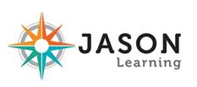
805 Brook Street, Building 4-CERC, Rocky Hill, CT 06067-3405 • Telephone: 860-571-7143
Email: acad@ctcase.org • Website: www.ctcase.org
CASE Member Portal: www.casemembers.wildapricot.org

Want to be a NOAA-it-all about the weather and oceans? Explore these fantastic FREE NOAA resources

NASA HAS MANY RESOURCES AVAILABLE TO EDUCATORS…MANY MORE THAN WE CAN DESCRIBE IN THIS NEWSLETTER. PLEASE EXPLORE WHAT IS AVAILABLE BY CLICKING ON
http://www.nasa.gov/audience/foreducators/index.html
and print publications click here to shop our entire NOAA publications collection.


MUSEUMS and INSTITUTIONS: the Connecticut State Museum of Natural History and Connecticut Archaeology Center, part of the College of Liberal Arts and Sciences at UConn. 860.486.4460 - www.mnh.uconn.edu
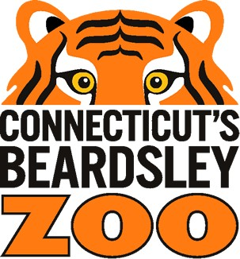
Connecticut's Beardsley Zoo is closer than you think and open daily from 9:00 am to 4:00 pm.

THE MARITIME AQUARIUM AT NORWALK, 10 N. Water Street, Norwalk, CT; (203) 852-0700, www.MaritimeAquarium.org. Hours: 10 a.m. to 5 p.m. daily.. IMAX® theater offers the largest movie screen in Connecticut. The name of the Aquarium's new research vessel will be R/V Spirit of the Sound – chosen through a recent Name the Boat contest open to Norwalk school students

For more information about The Maritime Aquarium’s educational programs, or its exhibits and IMAX movies, go to www.maritimeaquarium.org or call (203) 852-0700.

What Is Science Matters? Science Matters is an initiative by the National Science Teachers Association (NSTA) to bring content, news, and information that supports quality science education to parents and teachers nationwide. Science Matters builds on the success of the Building a Presence for Science program, first launched in 1997 as an e-networking initiative to assist teachers of science with professional development opportunities. Building a Presence for Science—now Science Matters—reaches readers in 34 states and the District of Columbia. Why does Science Matter? Science is critical to understanding the world around us. Most Americans feel that they received a good education and that their children will as well. Unfortunately, not many are aware that international tests show that American students are simply not performing well in science when compared to students in other countries. Many students (and their parents!) believe that science is irrelevant to their lives. Innovation leads to new products and processes that sustain our economy, and this innovation depends on a solid knowledge base in science, math, and engineering. All jobs of the future will require a basic understanding of math and science. The most recent ten year employment projections by the U.S. Labor Department show that of the 20 fastest growing occupations projected for 2014, 15 of them require significant mathematics or science preparation to successfully compete for a job. This is why Science Matters. Quality learning experiences in the sciences—starting at an early age—are critical to science literacy and our future workforce. Feel free to publish this information in school newsletters and bulletins, and share it with other parents, teachers, and administrators.

