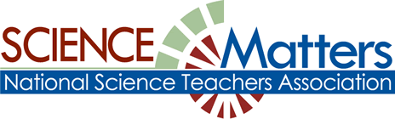

CONNECTICUT SCIENCE CONNECTION
February FIRST HALF 2016
The Connecticut Building a Presence for Science Network is sustained through the advocacy of the CCAT, Connecticut Science Supervisors Association, and the Connecticut Science Teachers Association

State Coordinator.David Lopath lopath@comcast.net
List Moderator..Eloise Farmer eloisef302@gmail.com

Names and e-mail addresses of our Points of Contact and Key Leaders are not shared with any other entitY

Resources

THIS MONTH’S FIRST ISSUE OF THE CSC IS BEING PUBLISHED A FEW DAYS EARLY BECAUSE SOME OPPORTUNITIES BEGIN ON FEB 1. A SECOND ISSUE WILL BE SENT OUT IN ABOUT 2 WEEKS with THE REST OF THE INFORMATION FOR FEBRUARY.
CONNECTICUT SCIENCE SUPERVISORS ASSOCIATION! Meeting of the Membership NON MEMBERS WELCOME! http://www.cssaonline.org/store/p11/Dinner_Meeting_February_24th.html for full details on how to register. DATE: Wednesday, February 24th, 5:00 - 7:30pm, (Snow Date: Wednesday, March 3, 2016), Peabody Museum, Great Hall of Dinosaurs, 170 Whitney Ave, New Haven, CT 06511. Parking: Directly adjacent to the museum (parking is free after 5pm), Event: “Three Dimensional Learning in Action”, The workshop will continue the 2015-2016 CSSA professional learning focus . Presenter: Sean Serafino
$35 members / $40 non-members (mail-in registration)
$37.50 members / $42.50 non-members (online registration - CLICK HERE)
SAVE THE DATES! CONNECTICUT SCIENCE SAFETY NETWORK CSSN 2015-16 WORKSHOP CALENDAR can be found at: http://www.wesleyan.edu/greenstreet/professionaldev/science_safety/2015-16%20CSSN%202015-16%20Workshop%20Calendar.pdf
PROFESSIONAL DEVELOPMENT

WORRIED ABOUT TEACHING THE ENGINEERING PARTS OF THE NGSS?
A new website from the National Academy of Engineering provides opportunities for connecting with educators who model engineering instruction and background information on engineering design. Go to www.linkengineering.org .
EECapacity, Cornell University, and other collaborators are offering a new online course called Environmental Education: Trans-disciplinary approaches to addressing wicked problems. As a participant in this course, you will have access to short lectures, readings, and multi-media resources contributed by over 40 US and global experts in environmental education and related environmental fields. And you will join an online community of environmental professionals from over 80 countries. Dates: February 1 – April 24, 2016 for 12-week Expert Certificate; February 1 – March 11, 2016 for five-week Achievement Certificate.
Cost: Free to participants who earn a Cornell University certificate of completion. For students wanting to earn undergraduate or graduate credits, University of Wisconsin-Stevens Point is offering the course for a fee. Course Goal: Participants gain the understanding, skills, and professional networks to work as environmental education professionals in concert with other disciplines and sectors to address environmental, sustainability, and conservation issues.
We encourage you to sign up with colleagues and form local or online groups to discuss the course materials and work together on the course project.
For more information including registration, course prospectus, list of instructors, and information about taking the course as a local or online interest group, go to: www.GlobalEE.net To begin meeting instructors and participants, join us on the course Facebook group: https://www.facebook.com/groups/GlobalEE/.
We look forward to your participation!
http://www.GlobalEE.net

A Winter of Webinars: Green Teacher's upcoming webinars are an interactive way for educators to continue learning about key environmental topics. Our professional development webinar series features some of the most important thinkers in the field of environmental education addressing vital and relevant topics. Five webinars are scheduled in the coming months. Registration is FREE and one can obtain a certificate upon completion. Learn more about each one and sign up now at http://greenteacher.com/webinars/ to ensure you don't miss out on any of the following:
Addressing Aquatic Invasive Species: Presenters: Bob Thomson and Brook Schryer, Tuesday, February 2 2015 7:30-8:30pm EST
Collecting Field Data on Local Birds with Elementary Students, Presenters: Renee Bachman and Ted Watt Thursday, February 4 2015 7:30-8:30pm EST
Remote Cameras in Environmental Education, Presenters: Ryan Pennesi and Dawn Tanner, Wednesday, February 10 2015 7:30-8:30pm EST
Subscribe to Green Teacher at http://greenteacher.com/subscribe/ and gain access to 55+ webinars and 300+ articles and activities, all cataloged according to 28 topics and various age groups. 1-year print $34 or 1-year digital $27.50. Tim Grant, Editor, Green Teacher, 28 Lennox Street #8, Toronto, ON M6G 1J4
416-960-1244, tim@greenteacher.com, US mailing address: Green Teacher, PO Box 452, Niagara Falls NY 14304

We're happy to announce that applications are now available for the 2016 MIT Science and Engineering Program for Teachers! This year, SEPT will be held during the week of June 21st:
Sunday, June 26 - Saturday, July 2, 2016 program. February 15th deadline. SEPT is a week-long residential program offered each summer at the Massachusetts Institute of Technology since 1989. Each year, we accept 25 outstanding educators from secondary schools worldwide who teach a range of subjects in science, technology, engineering, and math. The teachers who make the most of their week at MIT tend to:
- Integrate technology in their classrooms - particularly technology that enables students to create; and
- Demonstrate innovation in their teaching practice, and advancement through past professional development or other extracurricular experiences.
To apply, download and fill out the application from the SEPT webpage: http://sept.mit.edu by February 15th, and return your completed form and essay to Avi Ornstein (ornstein@alum.mit.edu ).
• Please contact Avi Ornstein ornstein@alum.mit.edu with questions. .Interested teachers should send their application to Avi Ornstein ornstein@alum.mit.edu rather than MIT, as the MIT Club of Hartford will be sponsoring one Connecticut teacher to attend.

January HAS gone by, so do not forget to submit your presentation ideas for this Spring’s COEEA Education Exchange- April 1 at Goodwin College. We are looking for ways to share on public engagement in citizen science programs, activities for general public use and classroom that increase knowledge of phenology, environmental quality and climate issues. This includes sharing of resources to encourage these areas of involvement.
Please take the time to send in your proposals to:.
Susan Quincy, Environmental Education Specialist
Connecticut Department of Energy and Environmental Protection
Kellogg Environmental Center, 500 Hawthorne Ave, Derby CT 06418
P: 203-734-2513 susan.quincy@ct.gov
www.ct.gov/deep

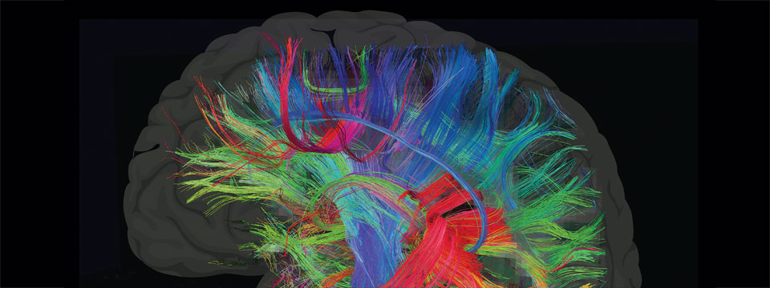
Bring new knowledge and excitement to your class this spring! The next session of Seminars on Science, the American Museum of Natural History’s online professional development program for educators begins March 14th. Graduate credit is available from our university partners.
The 6-week online courses co-taught by world-class museum scientists and classroom educators include The Brain; Climate Change; Earth: Inside and Out;Evolution; Genetics, Genomics, Genethics; The Ocean System; Space, Time and Motion; Water and more. Get access to cutting-edge research, rich content, and powerful classroom resources.
Sign up today and receive $50 off your registration fee! Use code SCIENCEMATTERS. If you have any questions, send us an email at learn@amnh.org, or call us at 800-649-6715.
For more information about the program, check out Seminars on Science at http://www.amnh.org/learn/

6-DAY EDUCATOR TRAINING WORKSHOP IN BERMUDA AT THE BERMUDA INSTITUTE OF OCEAN SCIENCE (BIOS) JUNE 20-25, 2016. This Educator Training Workshop offers middle and high school teachers, curriculum specialists, administrators, and informal educators the opportunity to learn how to plan and execute future educational field study courses for their students at BIOS. Between June 20-25, 2016, up to 12 participants will take part in this educational workshop and explore themes for potential future visiting groups
For further information please contact: Ed Argenta, BIOS educator: edandpat74@comcast.net
- See more at: http://www.bios.edu/education/educator-workshops-at-bios/

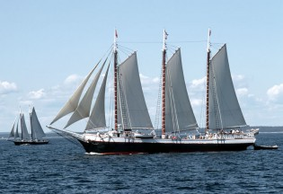
LEADERSHIP AT SEA: PROFESSIONAL DEVELOPMENT FOR TEACHERS
Mystic Seaport and the schooner Victory Chimes are pleased to offer a special joint professional development program for teachers. This is a unique, multidisciplinary teaching and learning experience that is designed to share the resources available to teachers at Mystic Seaport, and to provide an extraordinary environment for learning and connecting with others on board the schooner Victory Chimes, a national landmark vessel that represents our living heritage. This program can accommodate up to 24 teachers. Participating teachers will also learn how they can involve their school in the upcoming Leadership at Sea program for students in 2016-2017.
Shore Component: August 2-4, 2016 at Mystic Seaport
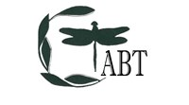
Sea Component: August 18-22, 2016 on board the schooner Victory Chimes, sailing out of Rockland, ME.
Cost: $1,295/person, includes room and board for entire program (if housing is not needed for shore component, subtract $80)
Shore Component at Mystic Seaport (August 2-4, 2016), Mystic CT
Sea Component on board Victory Chimes (August 18-22, 2016), Rockland, ME
Registration Information: Go to this registration form before April 30, 2016 and let us know if you are paying with a purchase order.
Please email registration form to: Kristi Otterbach, Breath Wind expressive arts and education. breathwind11@gmail.com
Mystic Seaport for Educators. Mystic Seaport hosts free monthly professional development workshops that provide teachers with “behind-the-scenes” tours and thematic workshops that correlate the Museum’s vast collections with classroom curriculum. Workshops show teachers how to utilize the Museum and its collections in their classrooms through active participation and interaction with experts, primary source documents, and exhibition objects. Topics range from immigration, whaling, and life at sea, navigation and nautical instruments to the Civil War and World War II. Each session will also highlight our website for teachers.

ETHNICALLY-DIVERSE CONNECTICUT TEACHERS!
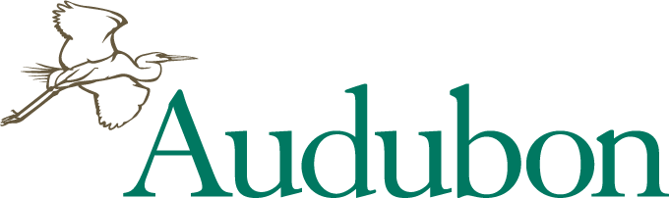
Enhance your environmental education methods and knowledge. We are awarding SIX 80% Scholarships for summer 2016 WHAT: Sharing Nature: An Educators’ Week Workshop WHERE: Hog Island Audubon Camp, Muscongus Bay, Maine
WHEN: JULY 17 - JULY 22, 2016
SCHOLARSHIP: $900 towards $1,095 registration fee (Price includes program, lodging, boat travel, all meals)
Features of Educators’ Week:
Hog Island Rainbow by Eric Snyder
- Designed for science and non-science educators to generate exciting ideas for creating and incorporating environmental education activities into your curriculum.
- Inspiring and experienced instructors will share their favorite approaches, methods, and activities for engaging you, and your students, with nature.
- Workshop presentations and guided field trips on the island share techniques in field biology, art, music, photography, theater, journaling, and other disciplines.
Interactive workshop: “Increasing Diversity in Environmental
Education” led by Chandra Taylor Smith, Ph.D. Vice President, Community Conservation and Education, National Audubon Society.
TO APPLY: E-mail letter of interest and names & contact info. of 2 professional references to Camp Director Pete Salmansohn at psalmansohn@audubon.org. Awards given on a rolling basis, so early application is strongly suggested. For details, photos, videos about the camp visit: hogisland.audubon.org.

SAVE THE DATE FOR The Connecticut Association of Biology Teachers Ideas and Innovations Professional Development Workshop! 8:30 am-3:30 pm April 9, 2016
Northwestern Connecticut Community College. Details and Registration forms will be posted on the CTABT website (http://web.ccsu.edu/ctabt/ ) in February.
CALL for WORKSHOP PROPOSALS! Would you like to share your favorite activity or lab exercise with other educators? Submit a proposal for the upcoming CTABT Ideas and Innovations Professional Development workshop at : https://www.surveymonkey.com/r/TDJJN2L or email Sharon Gusky, CTABT president at sgusky@nwcc.edu
Nominate an Outstanding Teacher : Every year, NABT and CTABT recognize an outstanding biology educator (grades 7-12 only) in Connecticut. Candidates for this award do not have to be CTABT or NABT members, but they must have at least three years of public, private, or parochial school teaching experience. A major portion of the nominee's career must have been devoted to the teaching of biology/life science. To nominate a candidate, go to http://www.nabt.org/websites/institution/index.php?p=631

REAL WORLD SCIENCE—YESTERDAY, TODAY, AND TOMORROW
How Necessity Creates Innovation in Science and Technology
July 17-22, 2016 in New Orleans, LA
The National WWII Museum is excited to announce a week-long professional development opportunity to take place in the summer of 2016 for middle school science teachers. Twenty eight teachers from across the country will come to New Orleans to experience hands-on how necessity, knowledge, perseverance and skill lead to inventions, innovation, and careers in STEM (Science, Technology, Engineering, and Mathematics), just like in World War II.
WHO CAN PARTICIPATE: The seminar application is open to any science teacher (public, public charter, private, and parochial) with between 2 and 10 years of teaching experience in 5th-8th grade science, and who will be teaching a science course to students in the same age group in the 2016-2017 school year. Applications will be evaluated through a competitive process that will include information on teaching experience, a short written statement, and two letters of recommendation. Two spots will be reserved for qualifying Louisiana teachers.
COST: This seminar is supported by a grant from the Northrop Grumman Foundation. Teachers will receive free room and board in New Orleans, a travel stipend, and all seminar materials free of charge.
http://www.nationalww2museum.org/learn/education/for-teachers/summer-teacher-seminar.html

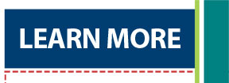
PlantingScience: Digging Deeper Together
A Model for Collaborative Teacher/Scientist Professional Development
BSCS, the Botanical Society of America, and the American Society of Plant Biologists are looking for high school life science teachers who are interested in participating in a unique professional development opportunity involving collaborations with research scientists, teachers, and students.
• Are you interested in collaborating with scientist mentors to help students learn how to conduct research on plants?
• Are you interested in taking part in face-to-face and online professional development to help enhance your teaching practices?
• Would you like to participate in a research project to find out how collaborations among teachers, research scientists, and students can lead to enhanced student learning?
• Are you interested in having your students work more with plants?
Digging Deeper is a professional development (PD) research project that builds on the success of PlantingScience, an online science mentoring community for high school biology students.
The Digging Deeper project will develop, implement, and test a professional development (PD) model whereby teachers and scientists work closely together over extended periods to guide students in authentic science investigations and then to reflect on instructional and mentoring strategies that are effective for enhancing student learning.

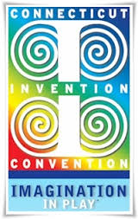
CIC Teacher Appreciation Luncheon, UConn, Storrs
Our Thank You to All CIC Program Teachers!
March 2016, Invention Convention Eventbrite - Teacher Appreciation Luncheon, Free!
http://www.ctinventionconvention.org/teachers-and-schools/teacher-training
Learn How Your Students Can Design and Make Almost Anything!
"I have a great idea, but I don't know how to make it!"
Have you or one of your students ever said that?
Fortunately, the technology is now available to enable anyone to design and make any part or component they might need for their inventions.
* Join us for an exciting hands-on professional development day! Perfect for Elementary and Middle school classes NO prior experience necessary The PD session will be taught by an experienced Middle School teacher who has been using this technology successfully in her classroom. She'll share her invaluable tips, tricks, and secrets so that you can use this technology in your classroom too!
At this session, you will learn how to use:
TinkerCAD – A free, easy to learn and use computer aided design program. Use simple geometric shapes to make anything. You don’t even have to be able to draw.
3D Printers – These amazing devices, which can make an actual 3D plastic product from your design, now cost less than $500. You will learn their features, capabilities and how to use them.
Project Ignite – A no-cost, on-line classroom management system, which you can use to direct and monitor your students’ work
P. O. Box 230311 Hartford, Connecticut 06123-0311
www.ctinventionconvention.org (860) 793-5299

Free, Online Access to JASON Learning’s Award-Winning Programs Available to Public School Educators in CT. Through generous support from the Connecticut Department of Economic and Community Development, JASON Learning is providing complimentary access to JASON’s gated website to all public school educators in CT through August of 2017. Each comprehensive JASON program highlights a diverse group of STEM role models, their research and real-world phenomena to engage students and motivate deeper interest in learning. JASON’s online platform includes reading selections, hands-on labs and field assignments, videos, digital simulations and learning games for students; and lesson plans, implementation tips, and a powerful classroom management tool for educators. Live, interactive events throughout the year connect JASON participants with inspirational STEM role models. Educators will have access to a host of downloadable resources from all 7 JASON Learning curricula.
Sign-up today by visiting www.jason.org : Login to JASON Mission Center and Register New Teacher Account!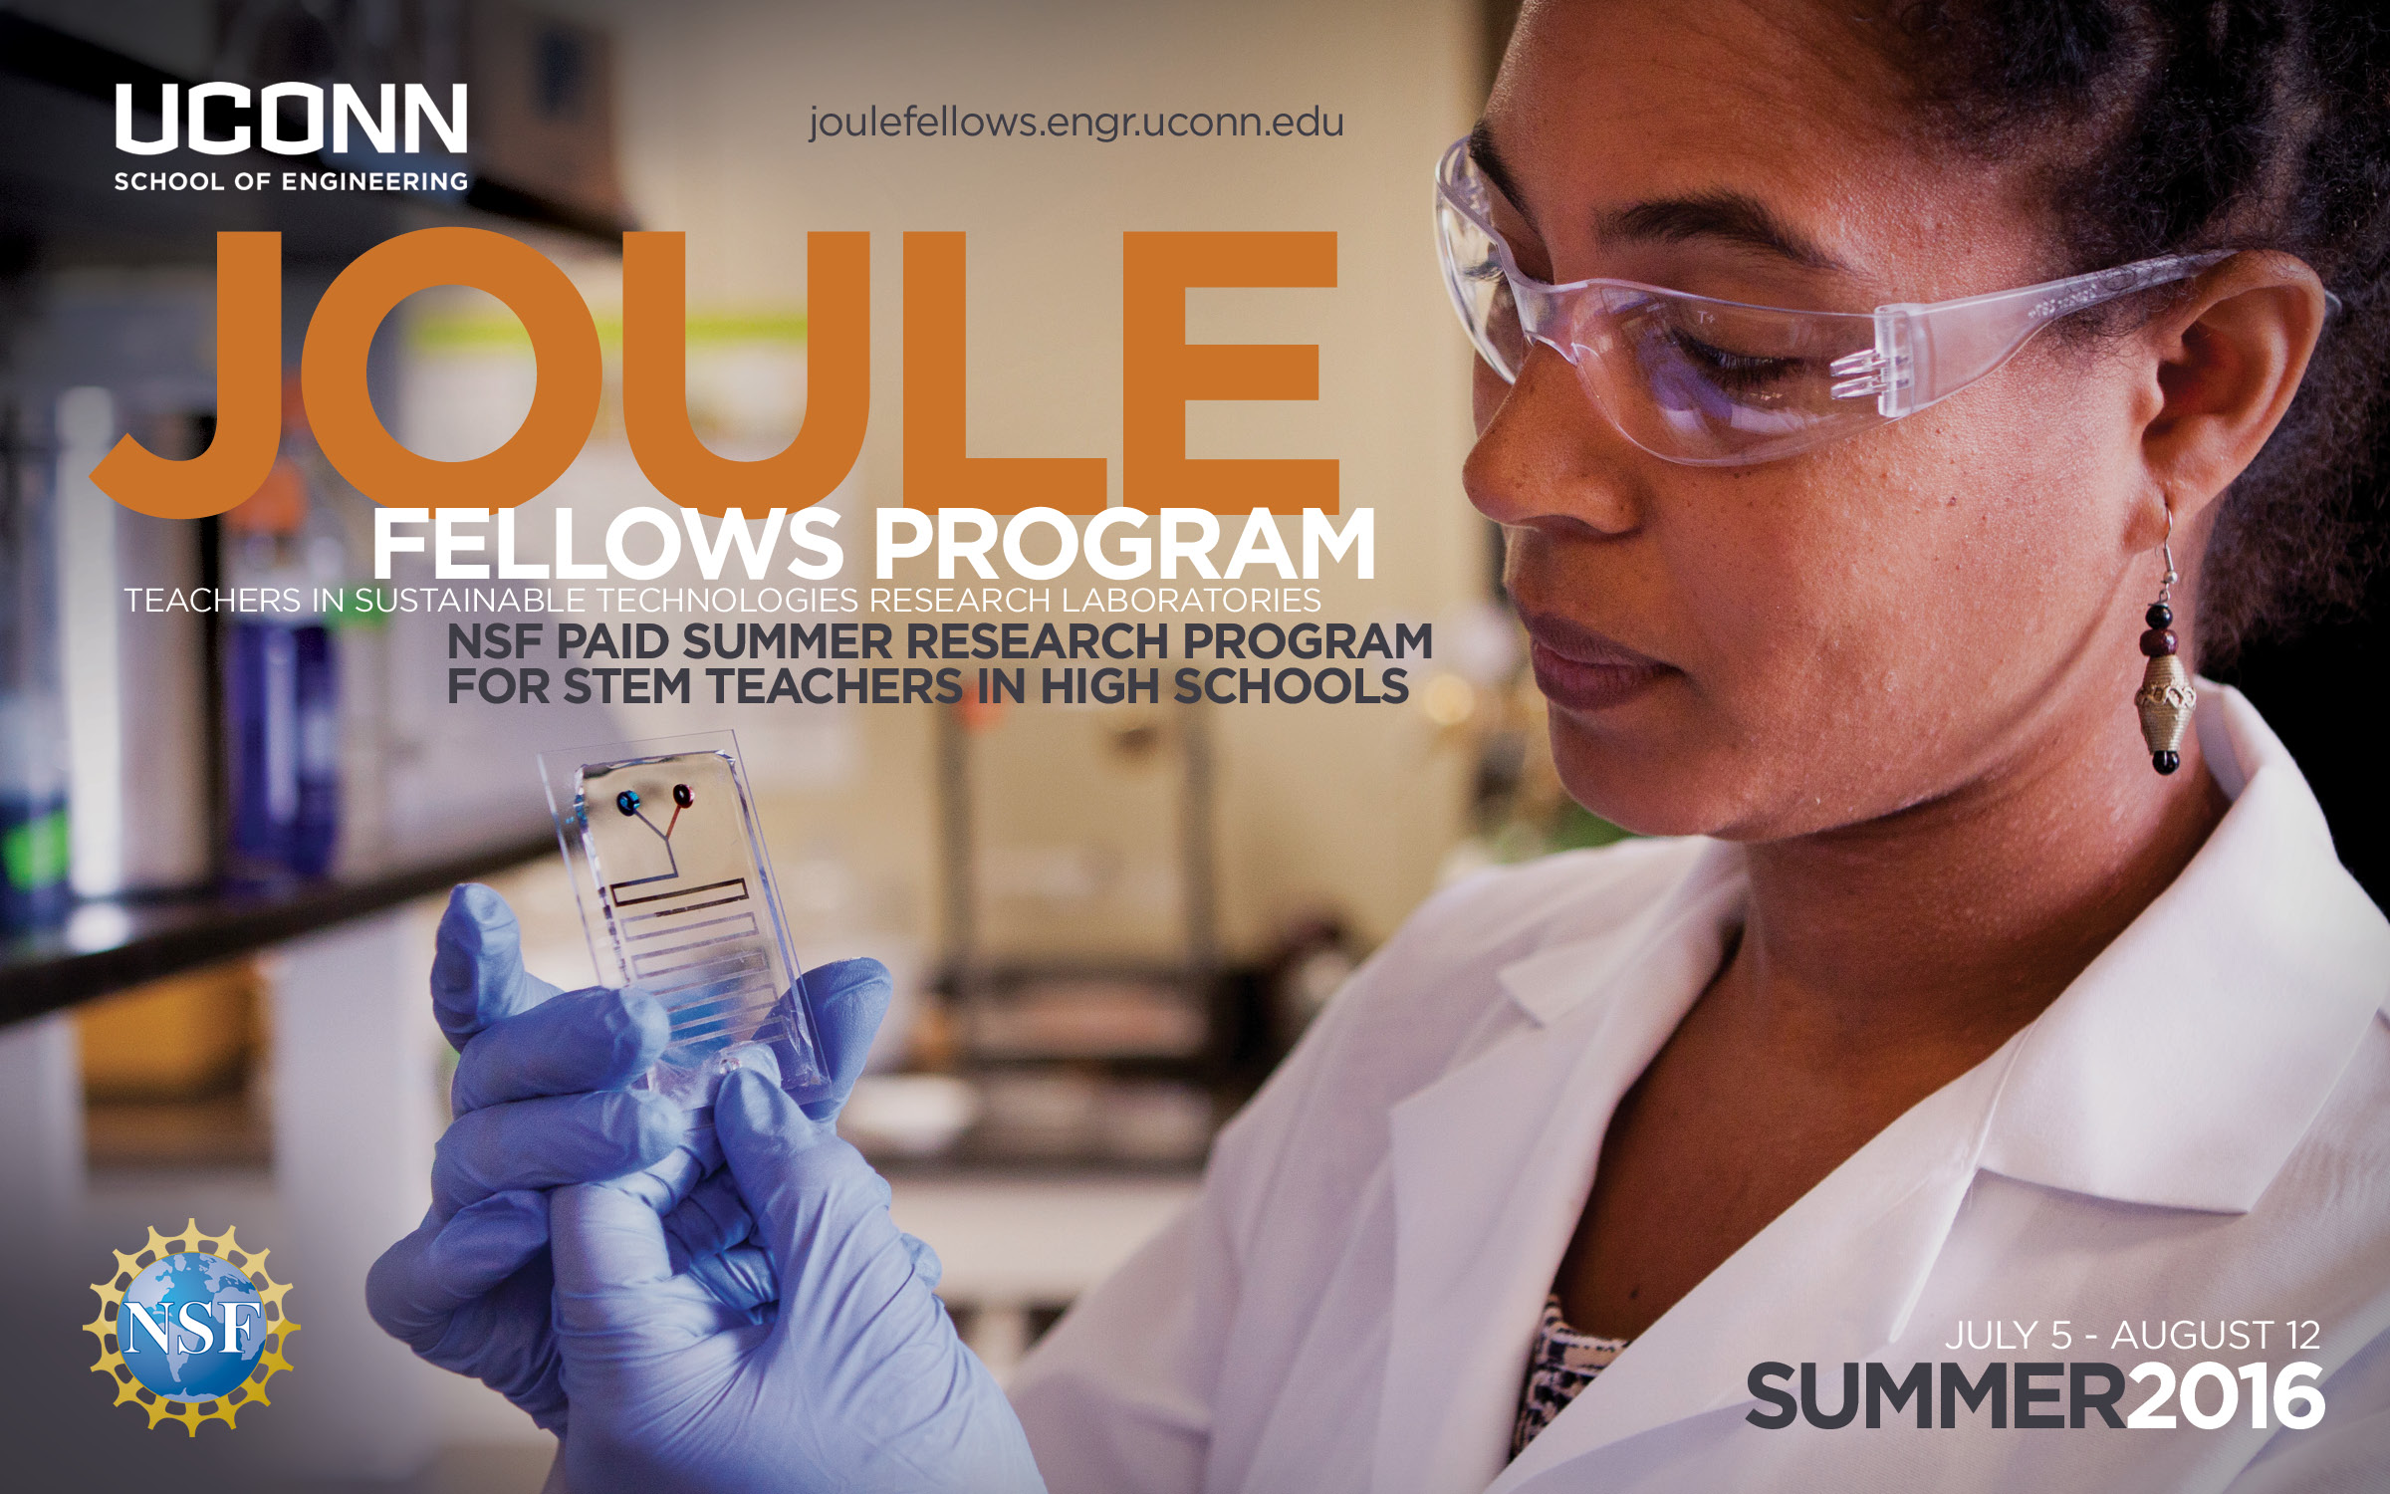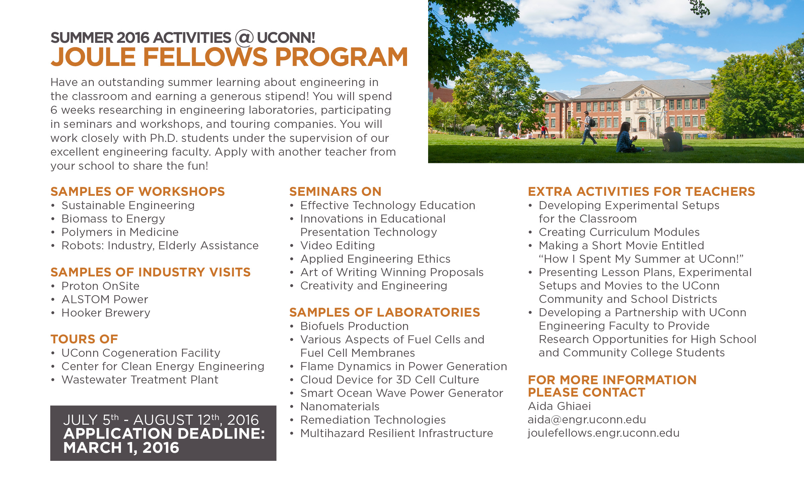
NSTA's National Conference in Nashville is the place to be to get hands-on learning on the Next Generation Science Standards (NGSS) and effective implementation strategies.

NSTA has an impressive line-up of NGSS-focused programs and events, including:

• NGSS-related short courses, such as Teaching NGSS in Elementary Grades and Building Better Lessons: NGSS Classroom Redesign
• A daylong NGSS@NSTA Forum comprised of five sessions given by NGSS writers and other education experts
• NGSS Share-a-thon providing tips and tools to implement three-dimensional standards
• Professional Learning institutes (PLIs) focused on three-dimensional learning
• Hundreds of sessions and workshops given by science educators, NGSS writers, and leaders from districts implementing the NGSS
• Inspiring and motivating speakers, including Peter McLaren from Achieve
Visit the NGSS@NSTA Hub to read more about these and many other NGSS-related events.

Earlybird deadline t o save $$ is February 5!
Take a Deep Dive Into the NGSS in Nashville
March 31 – April 3
National Middle Level Science Teachers Association is holding a Share-a-Thon on April 2, 2016 as part of our Meet Me in the Middle Day at the NSTA Conference in Nashville.

Participate in the Share-a-Thon. I hope that you will be able to distribute it to your state networks. Last year in Chicago we had well over 700 attendees visit the Share-a-Thon. Also participants as well as attendees are eligible for some of the great door prizes we have to offer. Register for Sharathon

You can get more information about Meet Me in the Middle day, by visiting our website:. http://nmlsta.ning.com/

PROGRAMS FOR STUDENTS:
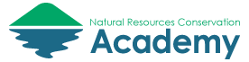UConn’s Natural Resources Conservation Academy (NRCA) http://nrca.uconn.edu/ ). UConn’s NRCA is an exciting program that engages high school students (grades 9 to 11) in natural resource conservation in their local community that is meaningful for the student, complementary to existing science curriculum, and beneficial to our communities and environment. First, students attend a week-long field experience at UConn in July. Afterwards, each student conducts a conservation project under the mentorship of a local conservation leader. Projects culminate in March, when students present their work at the Connecticut Conference on Natural Resources and graduate as “Connecticut Conservation Ambassadors.”
To date, we have worked with 92 students and 51 community partners on 74 conservation projects. It has been an enriching experience for both students, their partners, and their communities. This year we will be inviting teachers with students attending our program to participate in one of the field experience days as well. If you are interested in sharing this experience with your students, I would love to give a brief presentation (5-8 minutes) and answer questions. If time permits, I can also share a brief activity that we conduct during the NRCA field experience. Please feel free to contact Laura Cisneros via email (laura.cisneros@uconn.edu ) or phone (860-486-4917) to discuss the NRCA further.

 Eversource and The United Illuminating Company, as partners of the Energize Connecticut initiative, are now accepting entries for the 12th annual eesmarts Student Contest. The contest encourages students to demonstrate their knowledge of energy efficiency, renewable energy and sustainability by responding to grade-specific prompts or assignments. The eesmarts Student Contest is open to Connecticut students in Grades K-12. Additionally, new to the program this year is a college level playwright category entitled "Wright the World," and a new separate 12th grade category. Finalists in all categories and grade levels will be honored at a special awards ceremony on April 29, 2016 at the State Capitol in Hartford. Visit www.eesmarts.com/contest for contest guidelines, contest prompts and submission instructions. Deadline: April 1, 2016

HIGH SCHOOL SENIORS SOUGHT FOR NATIONAL YOUTH SCIENCE CAMP® HONORS
2016 National Youth Science Camp® Operated by the National Youth Science Foundation®
You are invited to nominate Connecticut high school seniors to compete for a full scholarship to attend the 2016 National Youth Science Camp (NYSC). NYSC is a summer residential science education program that creates opportunities for talented high school science students from all 50 states to exchange ideas with working scientists and other scholars from the STEM academic and corporate worlds. This month-long experience in Charleston, West Virginia, will include hands-on research projects with scientists from across the nation, overnight camping trips to the Monongahela National Forest, and a visit to Washington D.C.!
The NYSC experience is offered at no cost to participants since it is supported through contributions to the National Youth Science Foundation®. Educational and recreational programming, as well as meals, lodging, and round-trip air passage on scheduled airlines are provided free of charge to selected delegates.
The selected delegates must demonstrate academic achievement in science and show potential for thoughtful scientific leadership. Please see attached handout and visit www.nysc.org for more information.
Eligibility Requirements
▪ Must graduate from high school between July 1, 2015, and June 30, 2016;
▪ Must demonstrate superior academic proficiency, including recognition in mathematics and/or the sciences;
▪ Must demonstrate an application of leadership abilities and social maturity through involvement in both school and community activities;
▪ Must demonstrate skills and achievements outside the realm of science and outside the realm of academic pursuits; and
▪ Must demonstrate a curiosity and an eagerness to explore many and varied topics.
▪ MUST be able to attend the ENTIRE NYSC program, arriving in Charleston, West Virginia, on Wednesday, June 15, and departing on Sunday, July 10, 2016.
Applications:
• Application forms and additional information are available on the NYSC website at www.nysc.org.
• Completed applications must be received by Wednesday, February 17, 2016 at 6:00 p.m. EST.
• Application forms are available on the NYSC website at http://apply.nysc.org .

FOR MORE INFORMATION, CONTACT NYSC State Coordinator Dr. Terry Contant at 860-434-4800 ext. 172

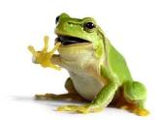
BE A CITIZEN SCIENTIST AND HELP FROGS AND TOADS!

FrogWatch USA is a citizen science program of the Association of Zoos and Aquariums (AZA) that provides individuals, groups, and families with an opportunity to learn about wetlands in their communities and report data on the calls of local frogs and toads. Volunteers collect data during evenings from February through August and have been submitting data for over 15 years. ( https://www.aza.org/frogwatch/ ).
The time commitment is just 5-10 minutes one or two times per week, 1/2 hour after sunset. One does not have to be a frog expert as training is provided!
Sponsored by Connecticut's Beardsley Zoo (http://www.beardsleyzoo.org/ ) and the Yale Peabody Museum of Natural History (http://peabody.yale.edu/ ), training is free for zoo or museum members and is $10 for non-member families and will take place on the following dates:
*Wednesday, February 17, 2016* (SNOW DATE: Friday, February 19, 2016)
Yale 1954 Environmental Science Center
http://peabody.yale.edu/collections/environmental-science-center >
Room 110, 7:00-9:00pm
And *Wednesday, February 24, 2016* (SNOW DATE: Friday, February 26, 2016) Hanson Exploration Station at Connecticut’s Beardsley Zoo
http://www.beardsleyzoo.com/ > 7:00-9:00pm
Pre-registration is necessary at least one week ahead: http://peabody.yale.edu/events/become-peabody-beardsley-frogwatch-citizen-scientist Training is also available at Mystic Aquarium and on-line: https://www.aza.org/become-a-frogwatch-volunteer/
Please join us! Gian A. Morresi, Environmental Educator, Connecticut’s Beardsley Zoo, 1875 Noble Avenue Bridgeport, CT 06610-1600, Phone: 203 394 6563
or 203 339 1001

Citizen Science Professional Development for Educators : Are you a formal or informal educator interested in Citizen Science? Learn how to integrate real-life science into your instruction and earn continuing education credits, all from the comfort of your own home! NEON’s Citizen Science Academy (CSA) offers online professional development courses for environmental science educators looking for out-of-the-box ways to teach scientific concepts by immersing your students in collecting, using and interpreting scientific data. By implementing citizen science projects, your students will contribute to research used by scientists all over the country. All CSA courses qualify for graduate-level continuing education credits from Colorado School of Mines.
Ready to learn how to incorporate citizen science projects into your classroom? Register for one of our courses starting February 2nd and April 4th. Learn more at http://CitizenScienceAcademy.org/online-courses. For more information contact: Dennis Ward, dward@neoninc.org , CSA | Course Administrator
NEON | Instructional Designer Boulder, Colorado, http://neoninc.org
http://CitizenScienceAcademy.org

RESOURCES:

2016 is the K-6 cycle for the Presidential Awards for Excellence in Mathematics and Science Teaching. Currently we have 10 science nominations and 9 mathematics nominations, only one of whom has begun the application process.

Plans for a face to face information session during the month of February are underway; further details will follow.
In the interim, information on upcoming support seminars for nominees and applicants can be found here: https://nsf.webex.com/mw3000/mywebex/default.do?siteurl=nsf&service=7

WATCH FOR ANOTHER ISSUE OF THE CSC IN A FEW WEEKS WITH MORE CURRENT SCIENCE INFORMATION and with OPPORTUNITIES FOR TEACHERS AND STUDENTS COMING THIS SUMMER !!

